**EmailAlertsOnWhatsapp**

**About**

This repository contains the code which fetches recent mails from a user's gmail account and send it to his/her Whatsapp account using the [Twilio environment](https://www.twilio.com/en-us)

**Prerequistics**

**App Passwords**

You can read more about [here](https://support.google.com/accounts/answer/185833?hl=en)

**Setup**

1.Create [Twilio Account](https://www.twilio.com/en-us) and connect your whatsapp number to it (It's free)

2.Go through the guide they provide and connect your whatsapp number such that you can send a message to the number and receive a message(Initially it would be something along the lines of "You send <your_message>")

3.Navigate to the function page through the navigation bar at the left

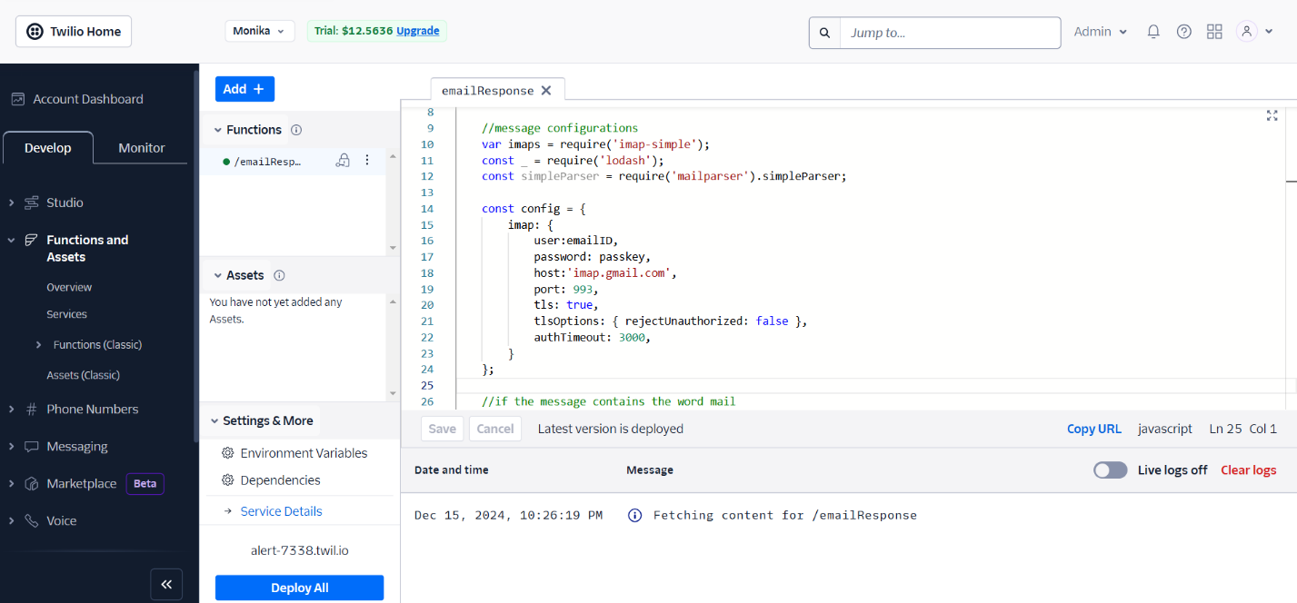

4.Create a new function (with any name you like) and copy the code in there.

5,Inside the functions page, go to settings->Dependencies and make sure you have all the dependencies added as shown in the figure

Dependencies

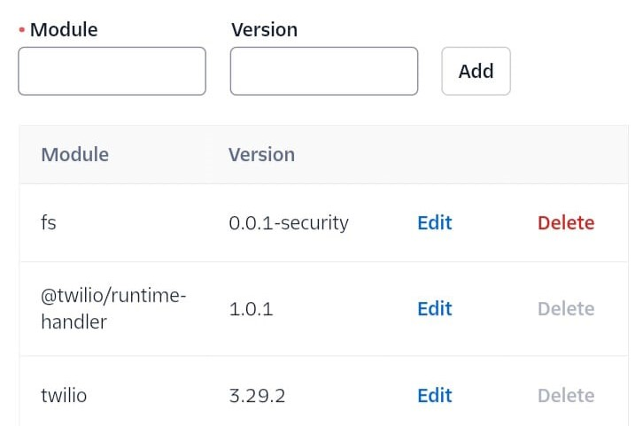 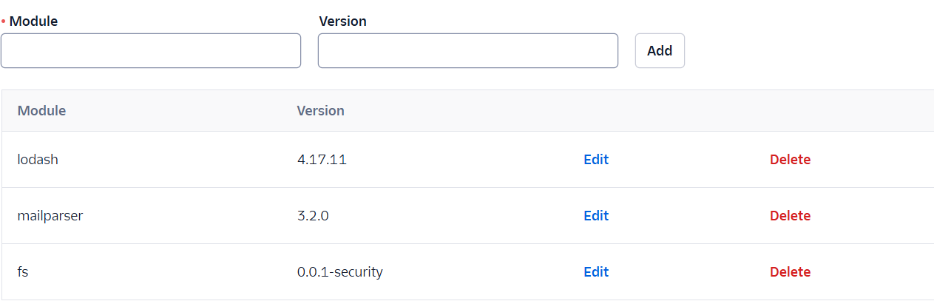

6.Now go to settings->Environment Variables and then set emailID as your GMail id and passKey as your App Password(If you don't know about app passwords please read the pre-requistic paragraph above)

**Environment variables**

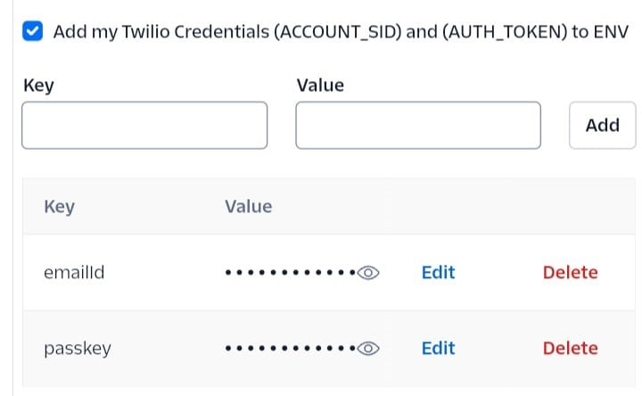

7.Save and select Deploy all

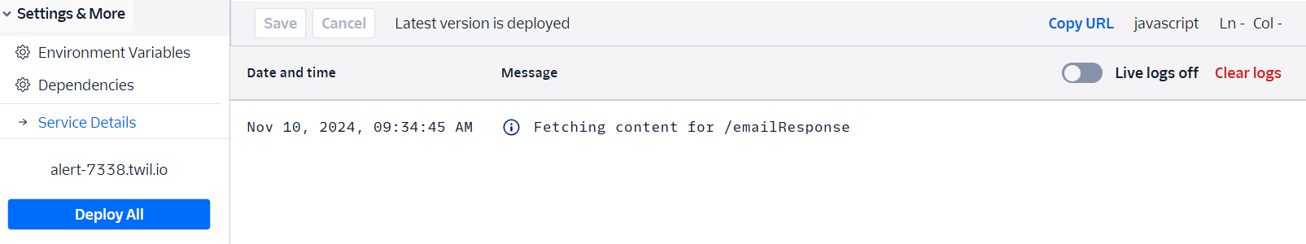

8.Select the 'Copy URL' present just below the code editor to copy the link of the function after deploying.

9.Now go to Programmable Messages->Settings->Whatsapp Sandbox Settings and paste the copied URL in step 8 into the 'WHEN A MESSAGE COMES IN' field in Sandbox Configuration

10.Save and you are good to go

**Features/Working**

The chatbot searches for keywords and replies accordingly. The followinf keyword are currently implemented.

1.Help : This gets the list of all keyword

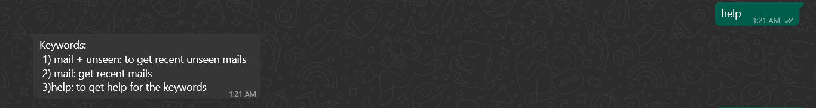

2.mail/email : This gets the recent 5 emails

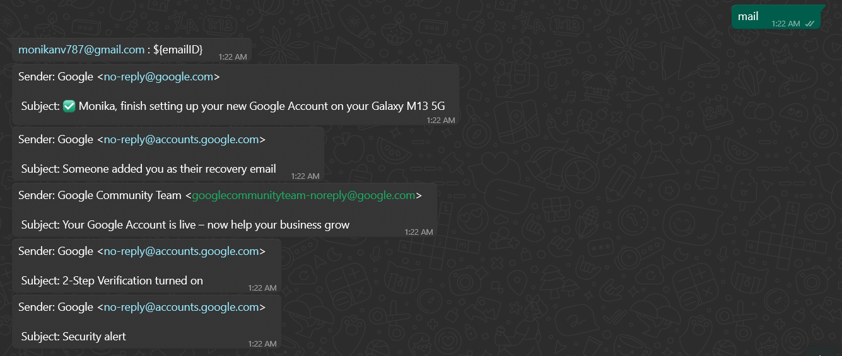

3.mail/email + unseen : This gets the latest unseen emails

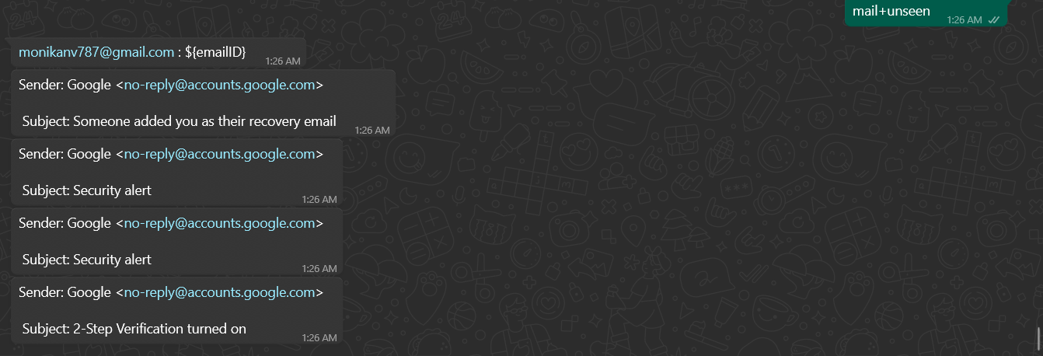

3.Hello/Hey : This just greets you and asks if you want to get mails. If you type es then it fetches the mails.



**Future Plans**

1.Add more functionalities/options with the email type being queried

2.Using some algorithm/AI to predict what the user is asking and reply accordingly. Currently it is hardcoded.

3.Add more features apart from email fetching (like weather, film reviews/recommendations) and turn it into a whatsapp assistant.